Lasallian Gateway Workshop
Opening Prayer

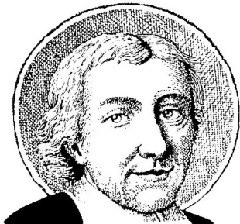
Leader: Let us remember
All: that we are in the holy presence of God.

Reader 1: The past is rich in storied wisdom. Lives given to service, filled with profound faith and passion, open to God’s transforming grace. Yesteryears hold the secrets of inner strength revealed, deep convictions sustained, and noble deeds realized.

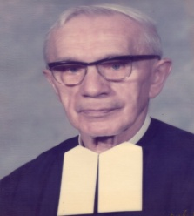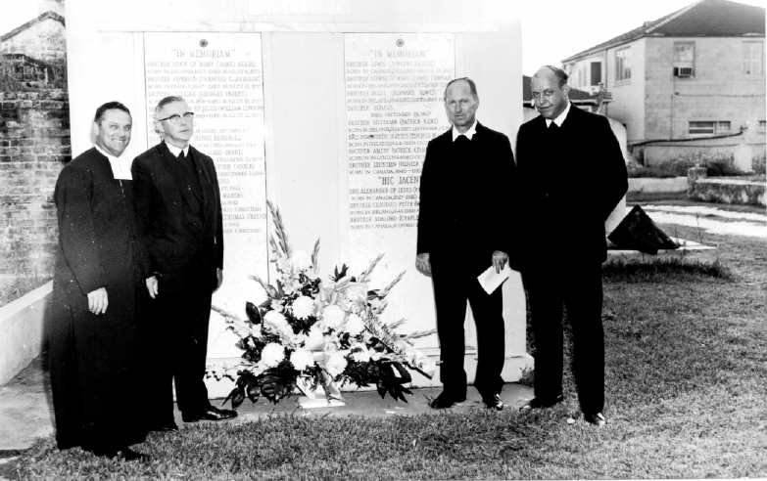
Bro. Charles Crouzet Brothers Cassian Lange, Charles Henry, Raphael Bodin, and Leo Harvey

Reader 2: We desire to work with our educational ancestors, the countless men and women who built, staffed and shaped our early schools.

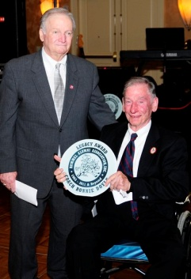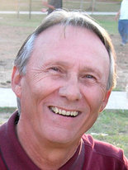
Mr. Ronnie Doyle and Bro. John Fairfax Coach Gene Bennett
Reader 3: We yearn to know the hearts and minds of these prophetic treasures who were the dreamers and visionaries, the leaders and decision makers, the truth seekers and the teachers.

Reader 4: We value their commitment and beliefs and seek their revelations and wisdom.

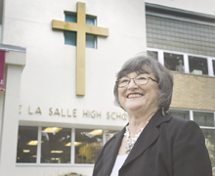I 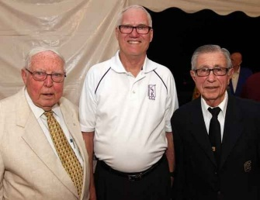
Mrs. Yvonne Gelpi Brothers Laurence Konersman and Amedy Esquibel

Reader 5: For each one is a blessing. Each one is a link in the wisdom story.

(pause)

Together: Behold, You desire truth in the innermost being, and in the hidden part, You will make
me know wisdom.

Reader 6: The future is rich in expectant wisdom. Lives given to opportunity, filled with potential
and promise, open to God’s transforming grace. Each day holds the mysteries of life
unfolding, growth occurring, opportunity beckoning.

Reader 7: We desire to nurture tender possibilities in the countless boys and girls who attend our
schools.

Reader 8: We touch the hearts and minds of those young treasures who are destined to become
the dreamers and the visionaries, the leaders and decision makers, the truth seekers
and the teachers.

Reader 9: We value their openness and eagerness and seek their revelations and truths. For
each one is a blessing. Each one is a link in the wisdom story.

(pause)

Together: Behold, You desire truth in the innermost being, and in the hidden part, You will make
me know wisdom.

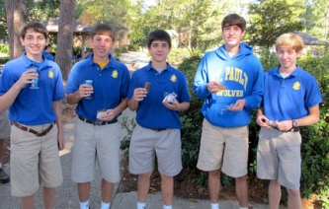

Scripture Reading: Matthew 19:13-15

Then children were brought to him that he might lay his hands on them and pray. The disciples rebuked them, 14g but Jesus said, “Let the children come to me, and do not prevent them; for the kingdom of heaven belongs to such as these.” 15 After he placed his hands on them, he went away.

From Saint John Baptist de La Salle: Meditation for the Time of Retreat #5

It is, then, not enough to procure the Christian spirit for children
and to teach them the mysteries and doctrines of our religion. You
must also teach them the practical maxims that are found throughout
the holy Gospel. But because they do not yet have a mind sufficiently
able to understand and practice these maxims by themselves, you
must serve as visible angels for them in two ways: 1) you must help
them understand the maxims as set forth in the holy Gospel, and 2)
you must guide their steps along the way that leads them to put these
maxims into practice.
For this they need visible angels, who by their instructions and
good example will encourage them to appreciate and to practice
these maxims. By these two means, then, these holy maxims will
make a strong impression on the mind and on the heart.
Such is the function you ought to perform for your disciples. It is
your duty to act toward them as your Guardian Angels act toward
you. You must win them over to practice the maxims of the holy Gospel,
and to this end you must give them means that are easy and accommodated
to their age. Gradually accustomed to this practice in
their childhood, when older they will have acquired these maxims as
a kind of habit and will practice them without great difficulty.

(pause)

Prayers and Petitions

Leader: Source of wisdom, help us to take inspired steps as we continue the educational
story started by our ancestors.

All: My mouth will speak wisdom, and the meditation of my heart will be understanding.
(Psalm 49:3)

Leader: Source of wisdom, help us to make wise decisions as we engage in our daily
ministry as teachers.

All: My mouth will speak wisdom, and the meditation of my heart will be understanding.
(Psalm 49:3)

Saint John Baptist de La Salle… Pray for us!
Live Jesus in our hearts…Forever!

Prayer and presentation courtesy of Charlie Legendre, AFSC, Director, Office of Education – Covington, District of San Francisco New Orleans

